Contents

WSL (Windows Subsystem for Linux): Ubuntu Commands 3

**Python Versions** Installation in Ubuntu: PyEnv 3

Commands executed in the PowerShell Console: 3

Commands executed in the WSL Console: 3

**GitHub** Installation in Ubuntu: GH 4

**Virtual Environment** Creation in Ubuntu with a Specific Python Version 5

Raise of Virtual Environment: 5

**Open WSL on VSCode** 5

**Error Handling:** Restart the virtual environment and Ubuntu Distribution 7

Commands executed in the PowerShell Console: 7

Read and Execute the Commands Included in the **README.md** File 7

**Error Handling:** **Workaround** for the error of Poetry **Access Issue:** 8

**PostgreSQL** Installation in Ubuntu: GH 11

Basenji Onboarding: 14

**Insomnium** 14

Kibana: 15

Pantheon ETL - Google Cloud Platform (GCP) 21

Jenkins 22

BIP: Basenji Intent Resolution 23

Canvas 23

# WSL (Windows Subsystem for Linux): Ubuntu Commands

The WSL console is a Windows Subsystem for Linux, which allows us to have versions (or distributions) of Linux like Ubuntu, Debian, etc. The WSL console with the Ubuntu distribution can be installed following these next steps, first executed in the PowerShell console and then inside of the WSL one, sometimes they switch by themselves, so got to be careful.

## **Python Versions** Installation in Ubuntu: PyEnv

**PyEnv** is a popular tool used on Ubuntu and other Linux distributions for managing multiple Python versions. It allows you to easily switch between different Python versions and manage project-specific Python environments, the installation process is the following: <https://help.clouding.io/hc/en-us/articles/13555555842588-How-to-install-different-versions-of-Python-on-Ubuntu>

### Commands executed in the PowerShell Console:

First, we must check that the Ubuntu distribution of Linux is already installed:

* wsl –list

### Commands executed in the WSL Console:

Then the terminal can change to WSL by itself if it’s the first time that we’re installing WSL, or we can open manually the console and run the next commands:

* sudo apt update && apt upgrade -y
* sudo python3 --version
* sudo apt install python3
* sudo apt install git curl make build-essential libssl-dev zlib1g-dev libbz2-dev libreadline-dev libsqlite3-dev wget llvm libncurses5-dev libncursesw5-dev xz-utils tk-dev libffi-dev liblzma-dev python3-openssl
* sudo apt install curl
* curl https://pyenv.run | bash

Now we must restart or open the WSL console and execute the following commands.

* echo 'export PYENV_ROOT="$HOME/.pyenv"' >> ~/.bashrc   
  echo 'command -v pyenv >/dev/null || export PATH="$PYENV_ROOT/bin:$PATH"' >> ~/.bashrc   
  echo 'eval "$(pyenv init -)"' >> ~/.bashrc
* export PYENV_ROOT="$HOME/.pyenv"
* [[ -d $PYENV_ROOT/bin ]] && export PATH="$PYENV_ROOT/bin:$PATH"
* eval "$(pyenv init - bash)"

Restart the WSL console and continue:

* cat ~/.bashrc
* pyenv install --list
* pyenv install 3.11.11
* pyenv global 3.11.11

Next run these two commands to confirm that the 2 versions of Python installed and running on the virtual environment are the same.

* python --version
* python3 --version

## **GitHub** Installation in Ubuntu: GH

To import a repository into the Linux distribution installed in the WSL, the following commands must be executed:

* sudo apt update
* sudo apt install gh
* gh auth login

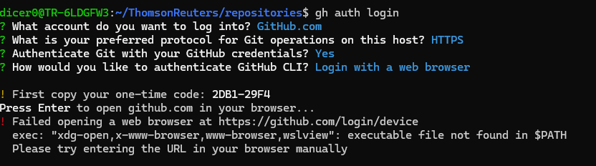

Optionally we can create folders for our repository pulls to be organized:

* mkdir ThomsonReuters
* mkdir Development
  + We’ll get into the development folder and there import all the repositories.

If we previously imported the repository into the root folder of the Ubuntu distribution, it can be moved with the mv command:

* mv ../../basenji/ .

To import a specific repository, we have to access its GitHub page and copy its GitHub CLI and finally run the command into the WSL console for it to be imported into the Linux distribution:

* **GitHub CLI:** gh repo clone casetext/basenji

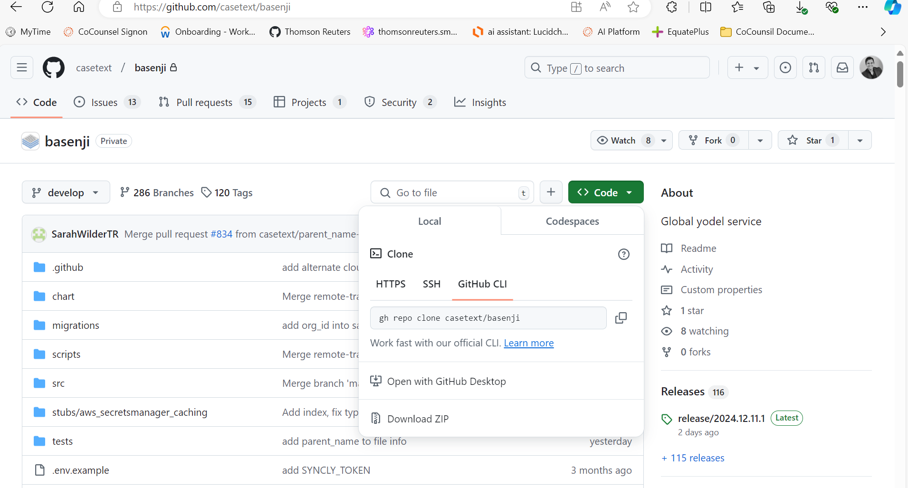

## **Virtual Environment** Creation in Ubuntu with a Specific Python Version

### Raise of Virtual Environment:

* sudo apt install python3-virtualenv

The folders of the Virtual Environment created will exist in the following directory, which can be accessed with the File Explorer or manually through its Linux/Ubuntu tab:

\\wsl.localhost\Ubuntu\home\dicer0\ThomsonReuters

These next commands must be executed to first create and then run the virtual environment:

* virtualenv -p **python3.11.11 .venv**
  + virtualenv -p **pythonSpecificVersion** **.EnvironmentName**
* source .venv/bin/activate

Now to open un the repository imported in the Visual Studio Code (VSCode) development we must follow these next steps:

## **Open WSL on VSCode**

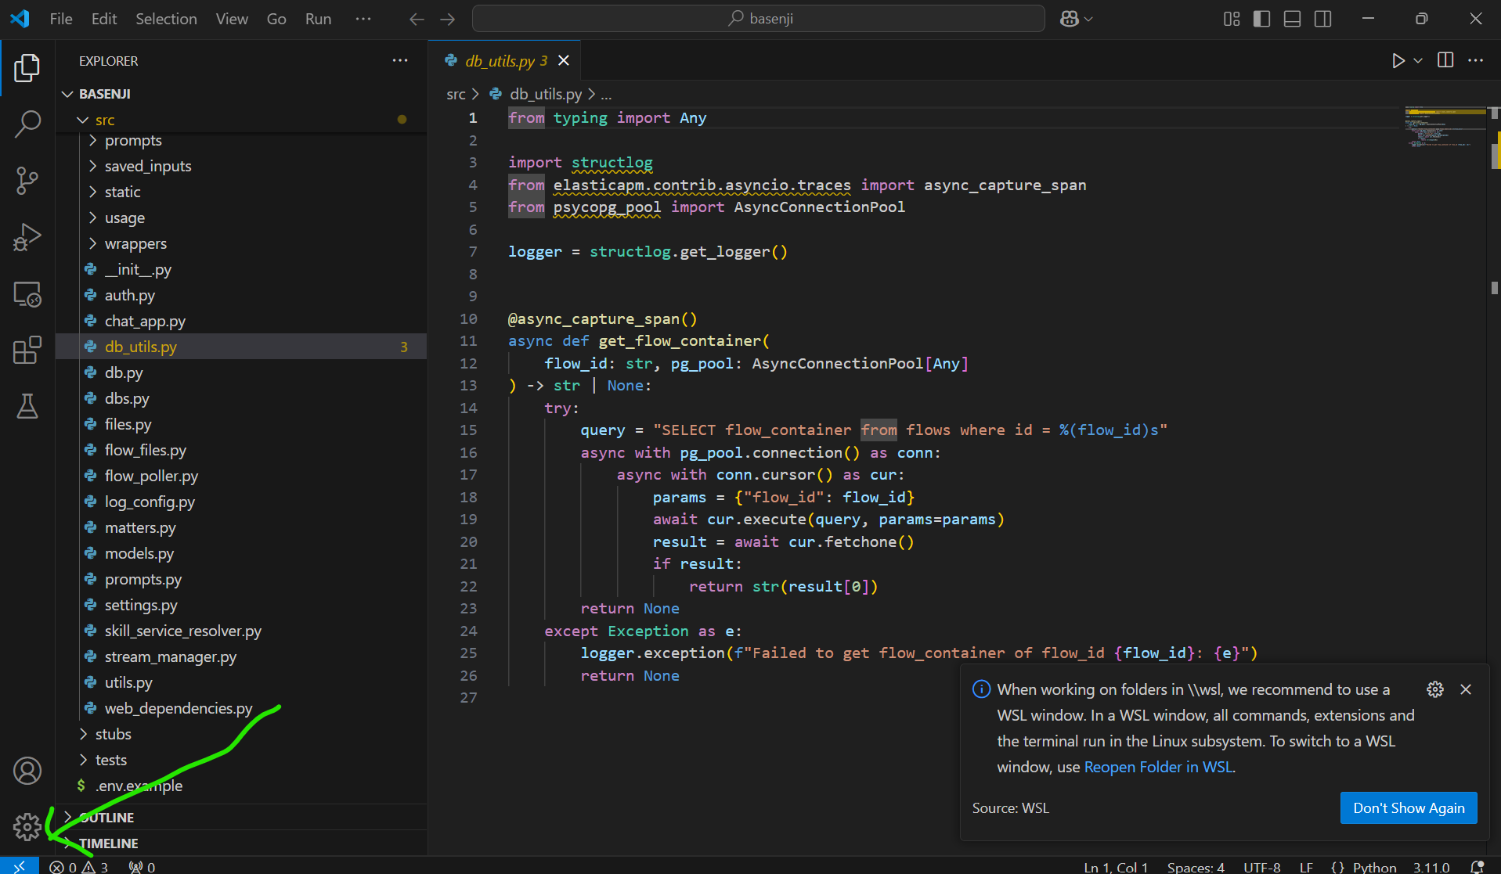

After choosing the WSL as designated console, Visual Studio will configure its terminal chosen and let us open its repository folder.

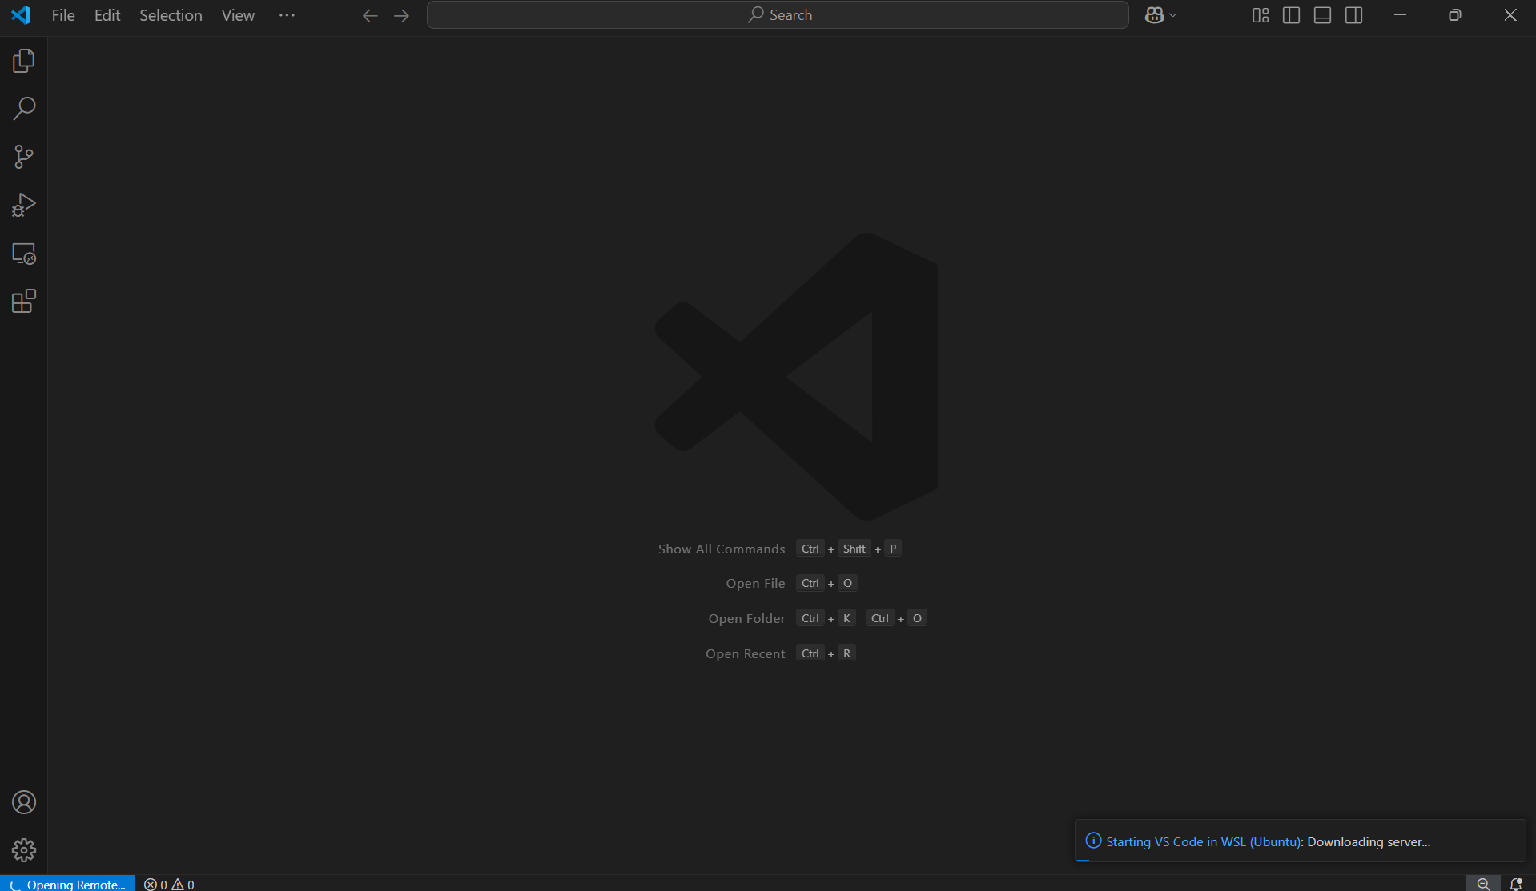 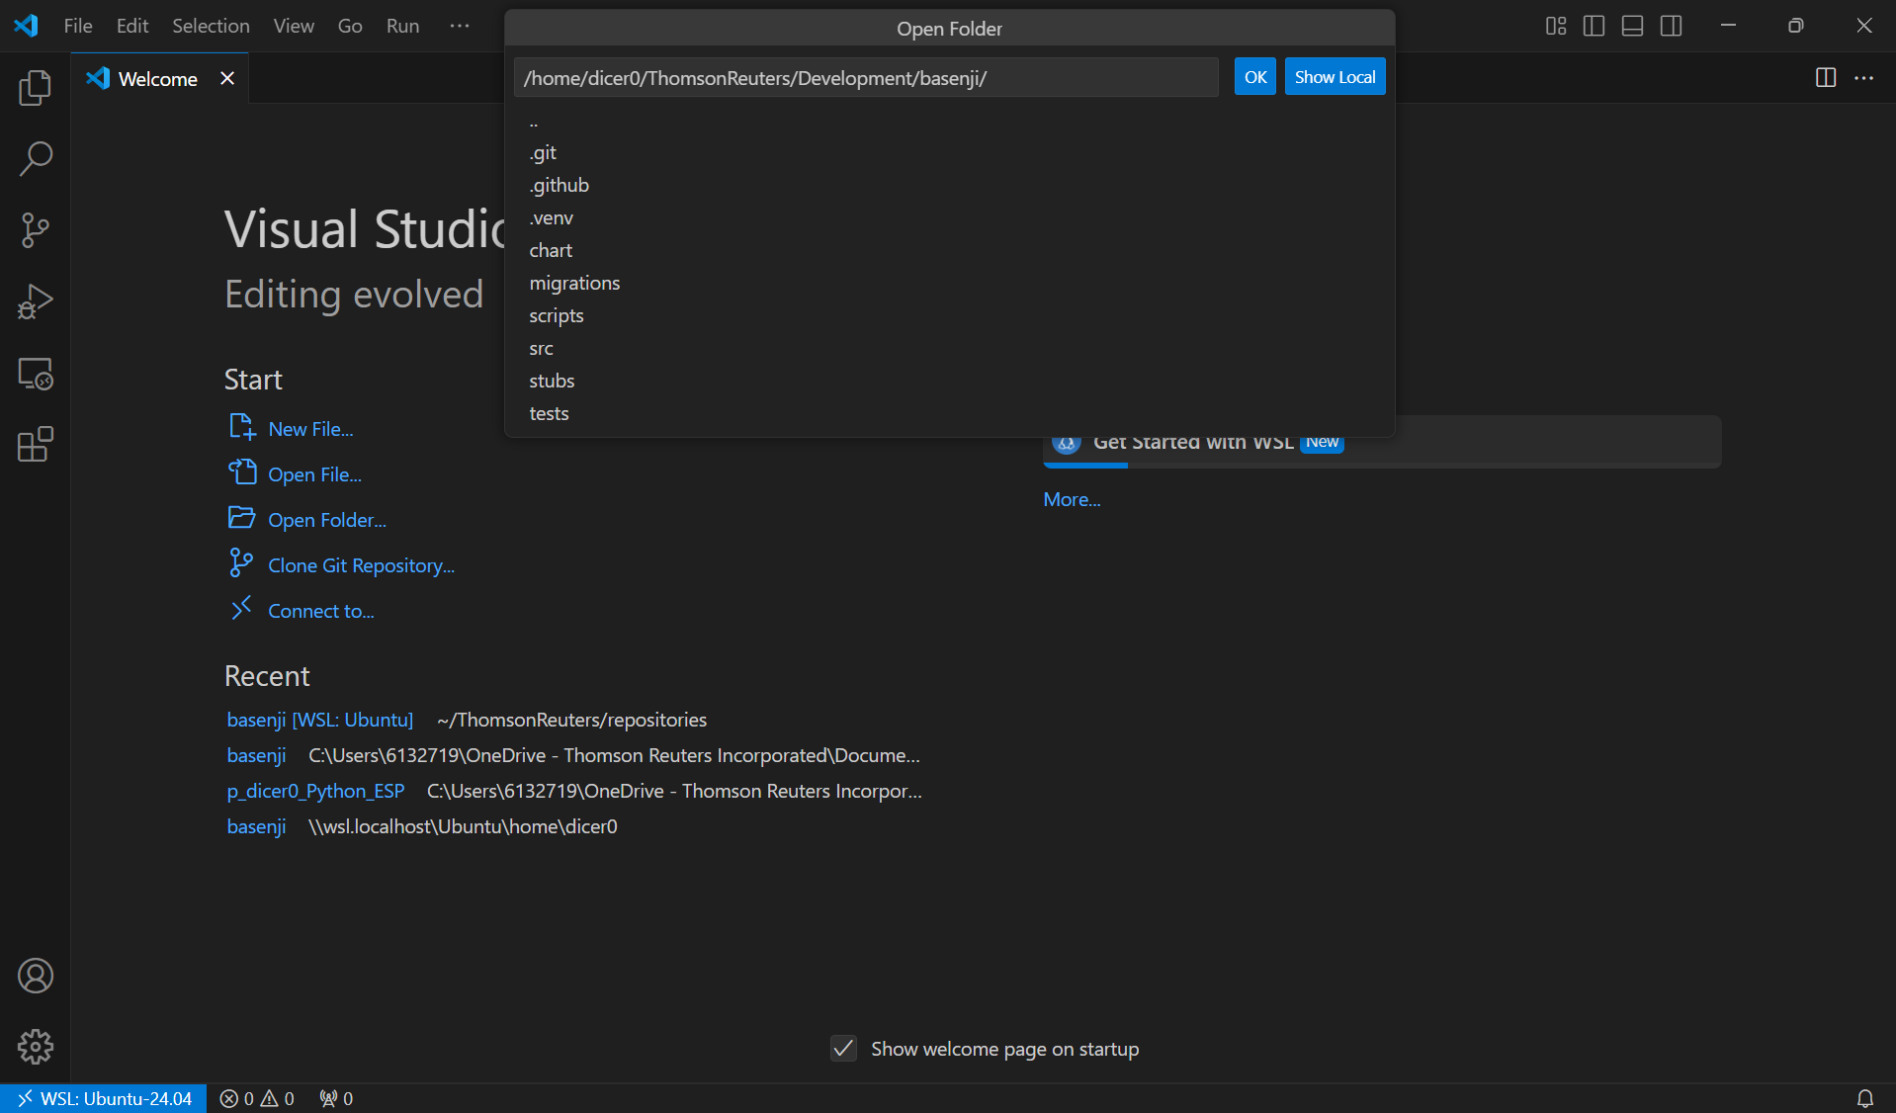

Then the Python Auto Venv extension activates automatically the virtual environment existent in the project folder, so that we don’t have to activate it manually every time.

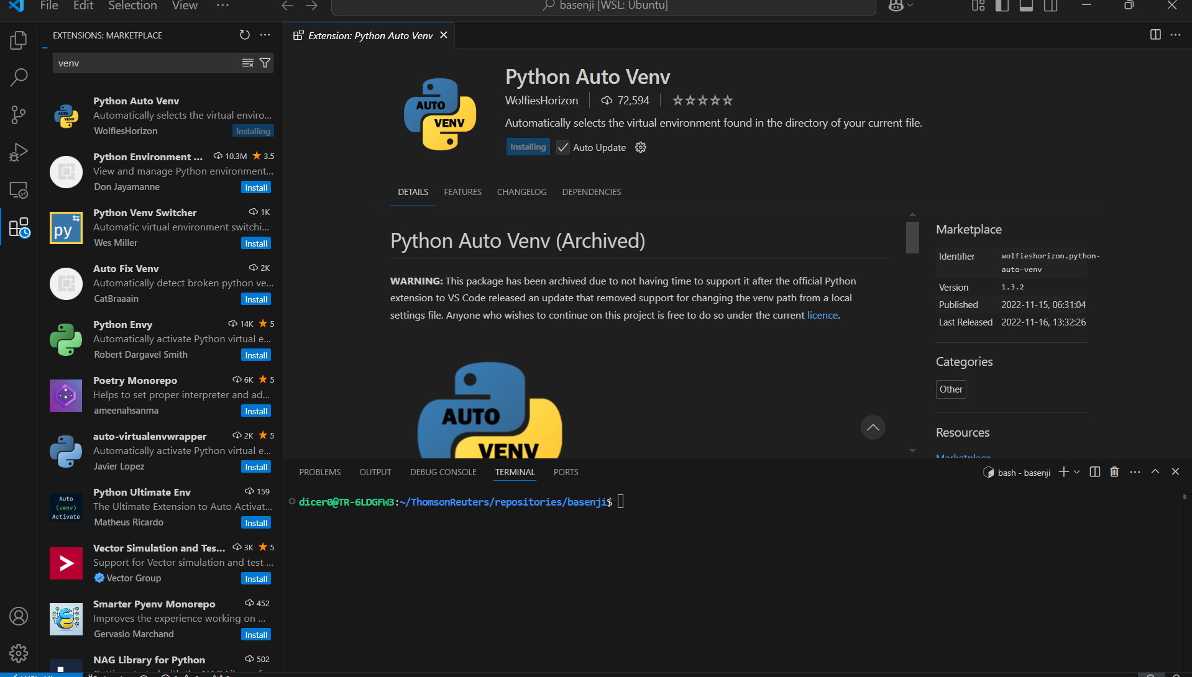

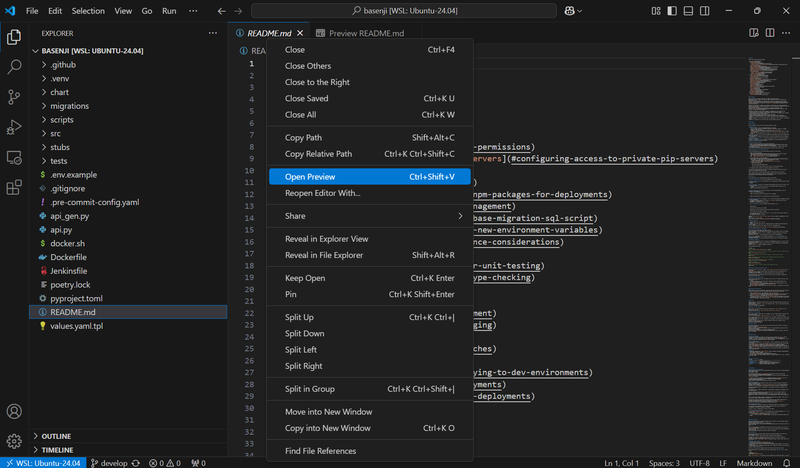

After everything’s installed correctly on VSCode, we must run this command for the repository to be opened inside the WSL console so that the Python Auto Venv opens up the virtual environment automatically:

* code .

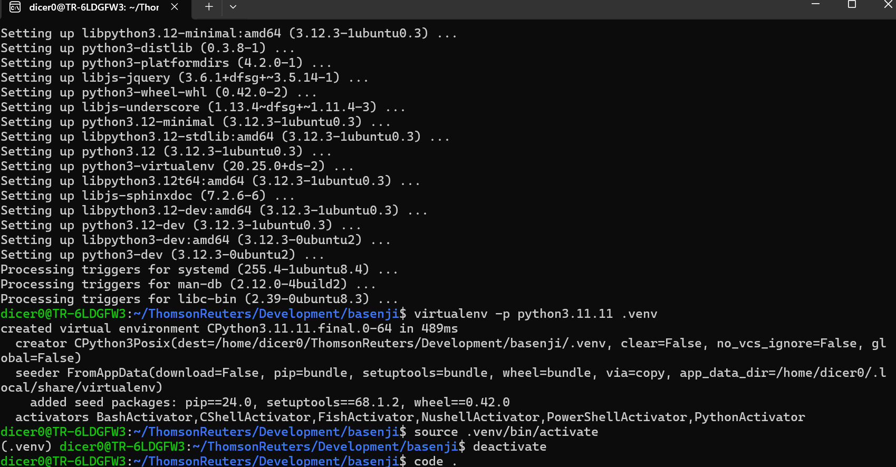

#### **Error Handling:** Restart the virtual environment and Ubuntu Distribution

If the packages in the Ubuntu virtual environment were wrongly installed or an error occurred, we can erase it and restart the process until this point executing the next commands, once the virtual environment is already activated:

* deactivate
* rm -rf .venv/
* virtualenv -p **python3.11.11 .venv**
  + virtualenv -p **pythonSpecificVersion** **.EnvironmentName**
* source .venv/bin/activate

### Commands executed in the PowerShell Console:

Then to restart the Ubuntu distribution we must run the following command inside of the PowerShell console:

* wsl --list
* wsl --unregister Ubuntu-24.04
* wsl --list
* wsl --install -d Ubuntu-24.04
  + Check in this directory that there are no folders or files left from Ubuntu:
    - *C:\Users\<YourUsername>\AppData\Local\Packages*

And now we must restart all the steps given from the start of this document.

## Read and Execute the Commands Included in the **README.md** File

In this file, we can find the instructions that we need to follow to install:

* Poetry, Google Cloud SDK, and Keyring Artifact Registry.

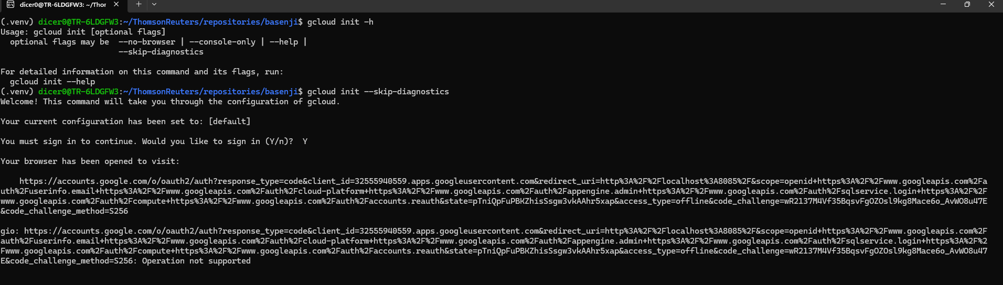

poetry install && poetry run fix_apm && poetry run pre-commit install

#### **Error Handling:** **Workaround** for the error of Poetry **Access Issue:**

Cada vez que se haga un cambio en estos repos, debemos actualizarlos manualmente, porque sino basenji dejará de funcionar.

gh repo clone casetext/basenji-intent-prompt

gh repo clone casetext/auth-library-py

Después de haber instalado los repositorios, debemos meternos al archive de pyproject.toml para que podamos usar los repositorios llamados.

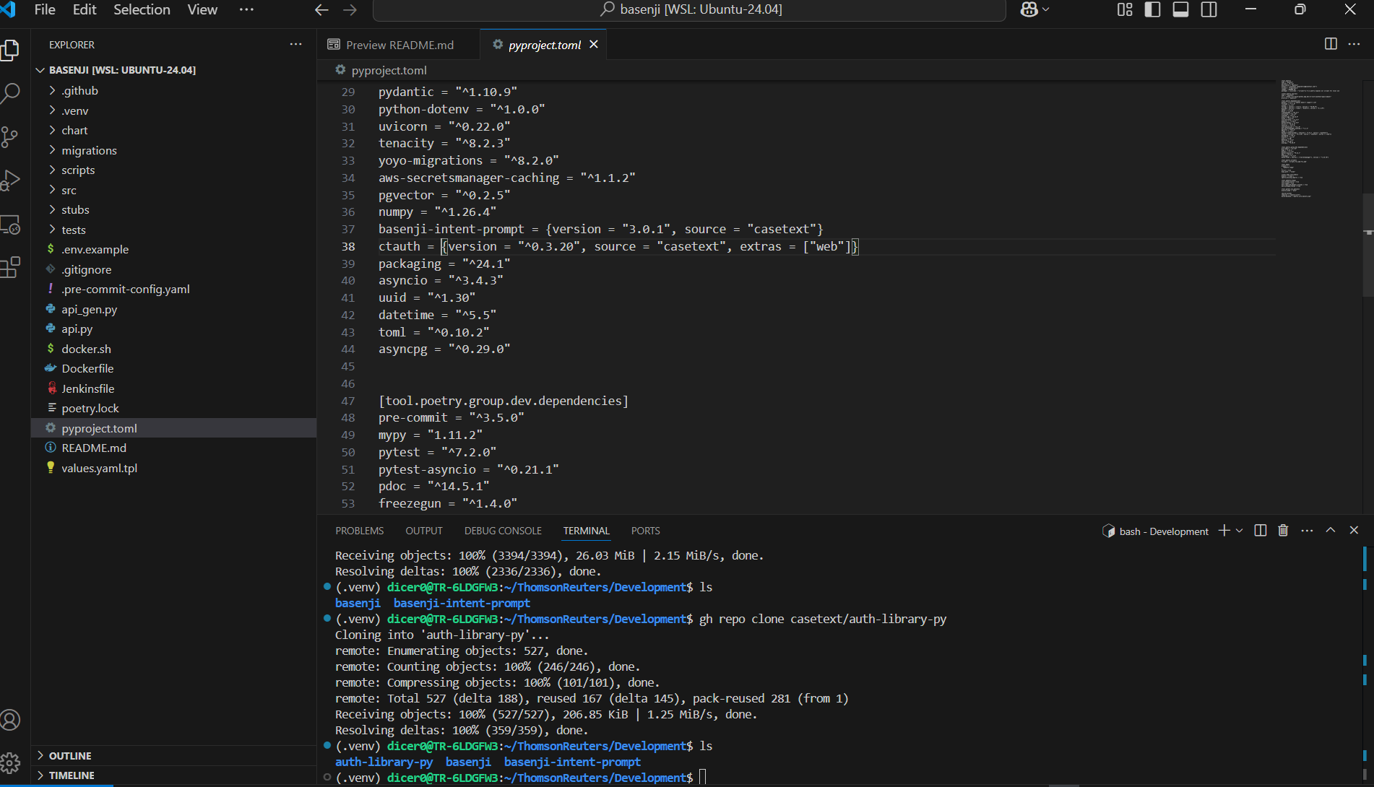

Se crea otro entorno dentro de BIP, esto mismo se repite para Ctauth

* deactivate
* virtualenv -p **python3.11.11 .venv**
  + virtualenv -p **pythonSpecificVersion** **.EnvironmentName**
* source .venv/bin/activate

Y se instala

pip install poetry

poetry install

poetry build

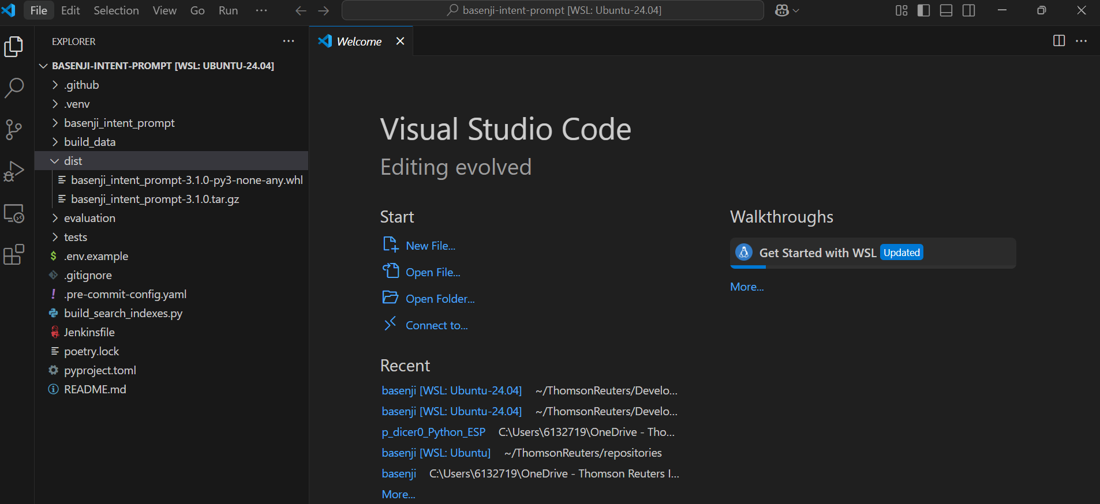

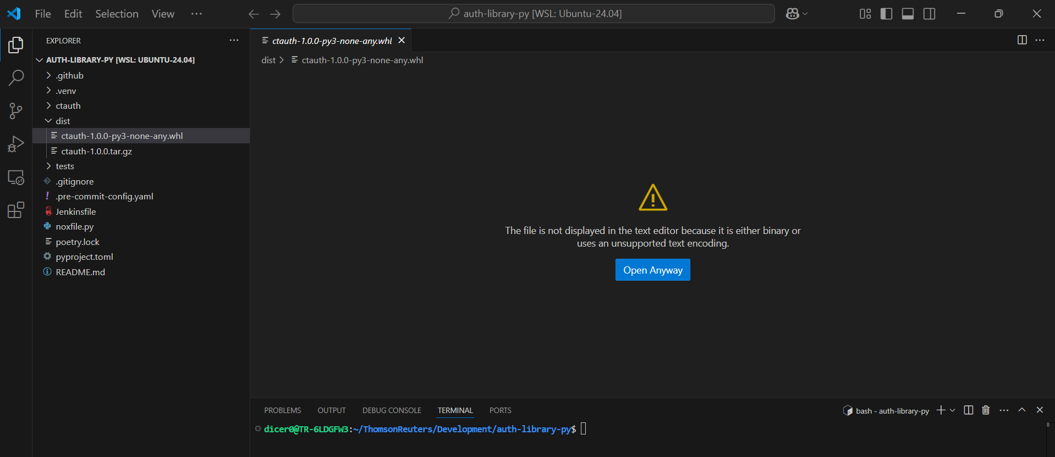

Cada vez que haga build, tendré un archivo distinto, este es el wheel de poetry y se puede instalar directamente, este es el que se instala desde el entorno virtual de basenji

pip install ../basenji-intent-prompt/dist/basenji_intent_prompt-3.1.0-py3-none-any.whl

pip install ../auth-library-py/dist/ctauth-1.0.0-py3-none-any.whl

Y ya con eso se puede corer basenji con el siguiente commando:

python api.py

## **PostgreSQL** Installation in Ubuntu: GH

To install the PostgreSQL database and PgAdmin RDBMS (Relational Database Management System) we must follow the steps given in the Postgres official download site, inside of the Linux/Ubuntu section:

[PostgreSQL: Linux downloads (Ubuntu)](https://www.postgresql.org/download/linux/ubuntu/)

* sudo apt install postgresql
* sudo apt install curl ca-certificates
* sudo install -d /usr/share/postgresql-common/pgdg
* sudo curl -o /usr/share/postgresql-common/pgdg/apt.postgresql.org.asc --fail <https://www.postgresql.org/media/keys/ACCC4CF8.asc>
* sudo sh -c 'echo "deb [signed-by=/usr/share/postgresql-common/pgdg/apt.postgresql.org.asc] https://apt.postgresql.org/pub/repos/apt $(lsb_release -cs)-pgdg main" > /etc/apt/sources.list.d/pgdg.list'
* sudo apt update
* sudo apt -y install postgresql

And then to configure and install PgAdmin to have a graphical database management system, we must access the pgadmin official site and follow these next steps:

[Download](https://www.pgadmin.org/download/pgadmin-4-apt/)

* curl -fsS https://www.pgadmin.org/static/packages_pgadmin_org.pub | sudo gpg --dearmor -o /usr/share/keyrings/packages-pgadmin-org.gpg
* sudo sh -c 'echo "deb [signed-by=/usr/share/keyrings/packages-pgadmin-org.gpg] https://ftp.postgresql.org/pub/pgadmin/pgadmin4/apt/$(lsb_release -cs) pgadmin4 main" > /etc/apt/sources.list.d/pgadmin4.list && apt update'

Install and run the .exe file that is obtained from the same PgAdmin official site, after that, we can continue executing the next commands:

* sudo apt install pgadmin4
* sudo apt install pgadmin4-desktop

Then we must create a new server through the option of **Servers** → Register → Server… → **General** → *Name:* Database_name → **Connection** → *Host name:* localhost → *Port:* 5432 → *Password:* database_password. At this point where the password is generated, we must first set it inside of the Ubuntu environment through the WSL console with the next commands:

* sudo -u postgres psql
  + alter user postgres with password ‘password’;
  + exit

Copy and paste the password indicated in the last command inside of the PgAdmin Register - Server window and finally click on Save.

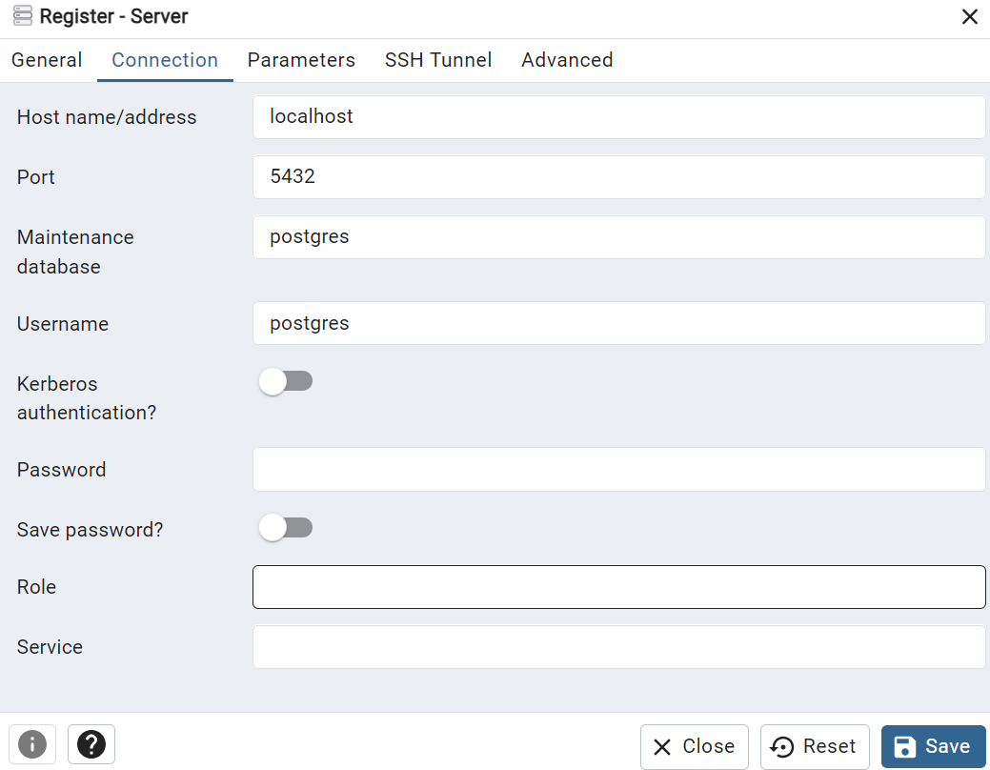

Then we must create a test database with the option of **Databases** → Create → Database…

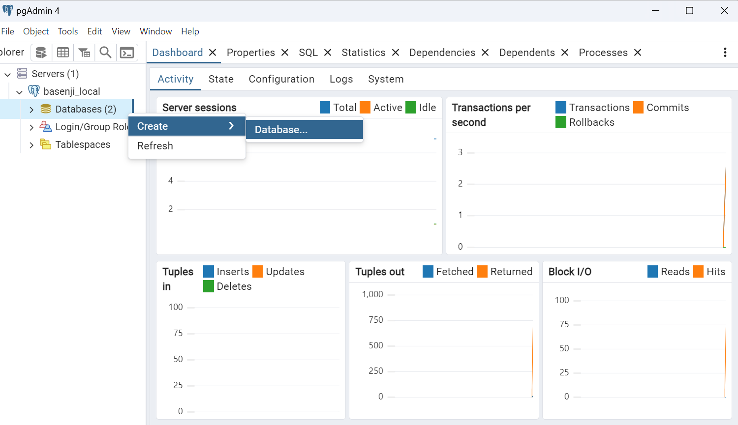

# Basenji Onboarding:

Pycharm = Testing?

Poetry = Install

## **Insomnium**

Insomnium = Postman

<https://github.com/ArchGPT/insomnium>

authenticate token

[casetext/auth-library-py: Auth libraries for Casetext and TR auth services](https://github.com/casetext/auth-library-py)

# Kibana:

APM = Error handling for 401, 402 and 403 HTTP status

401 is successful, not having the x token flag

403 is the wrong product id

NSAC connection between basenji, pantheon and the React.js frontend

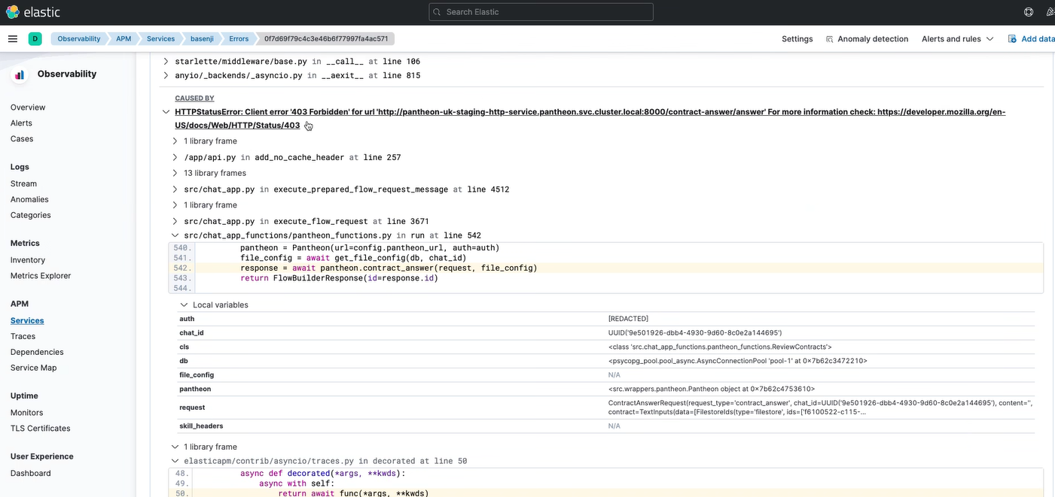

ONEPASS authentication

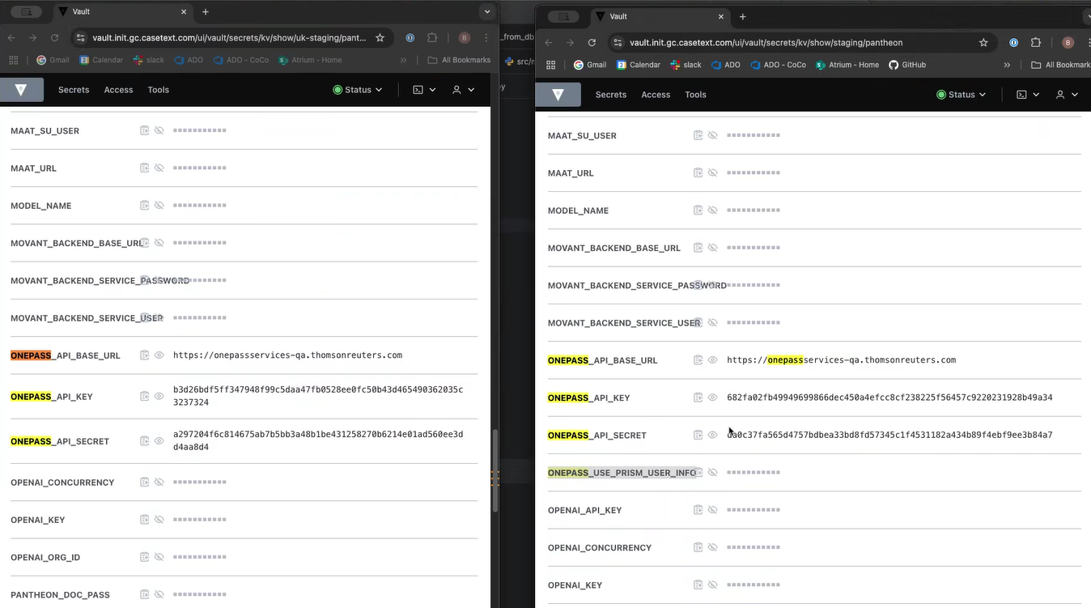

Ctauth python library

Transactions = Checking errors

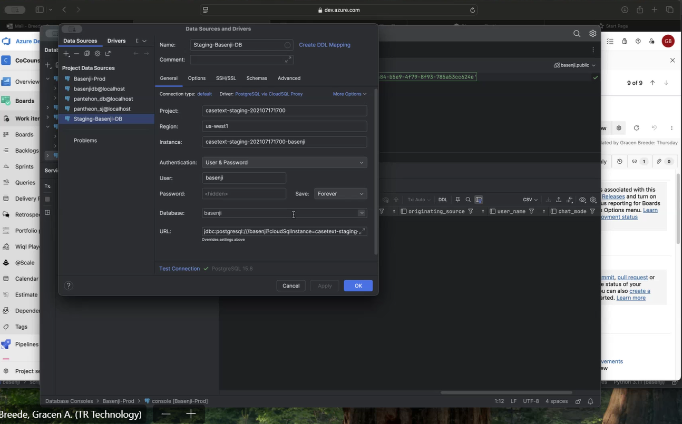

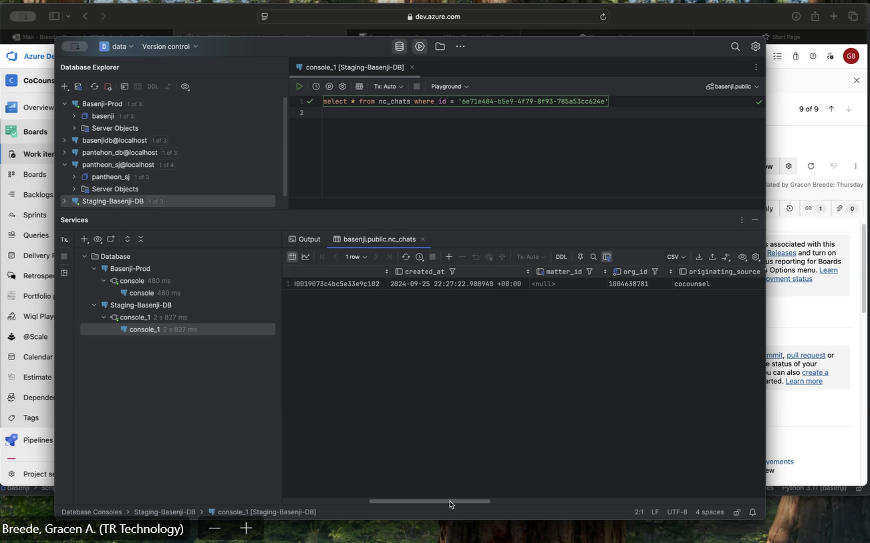

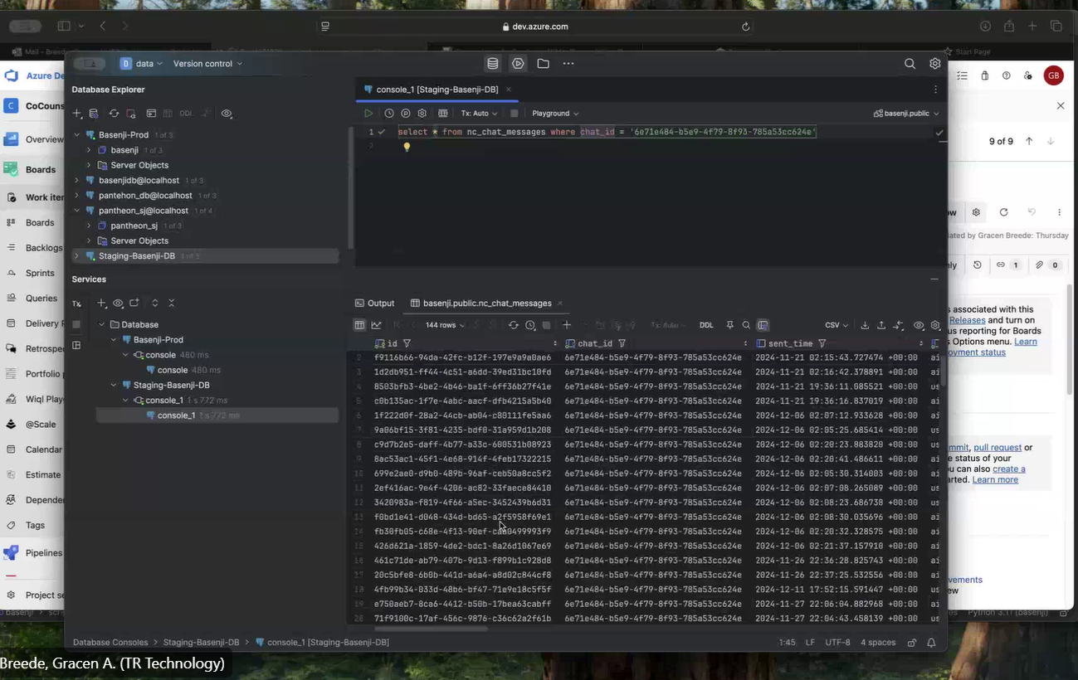

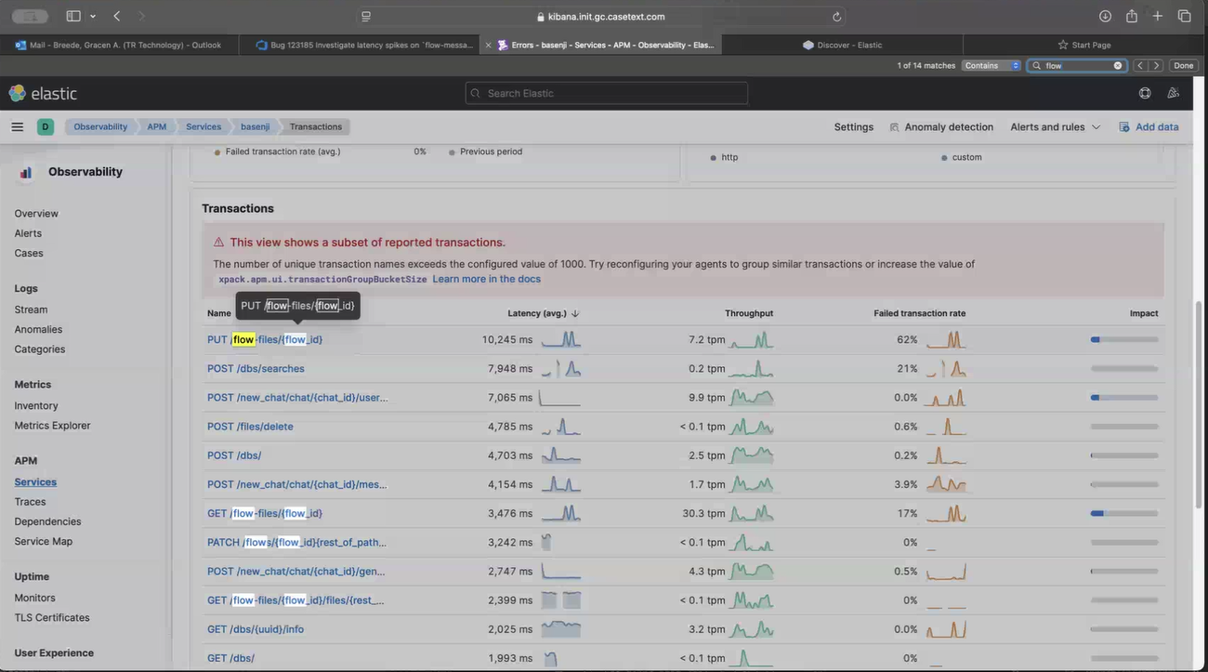

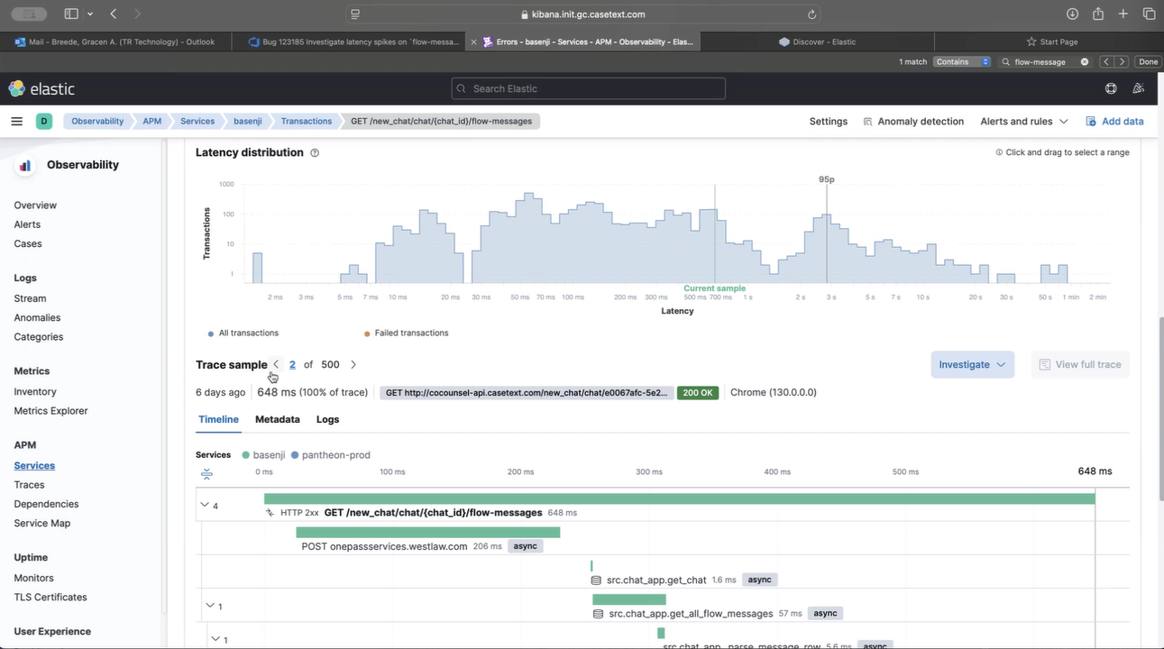

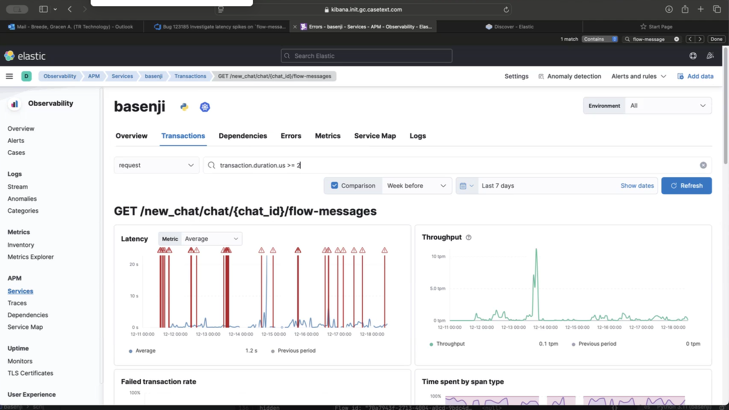

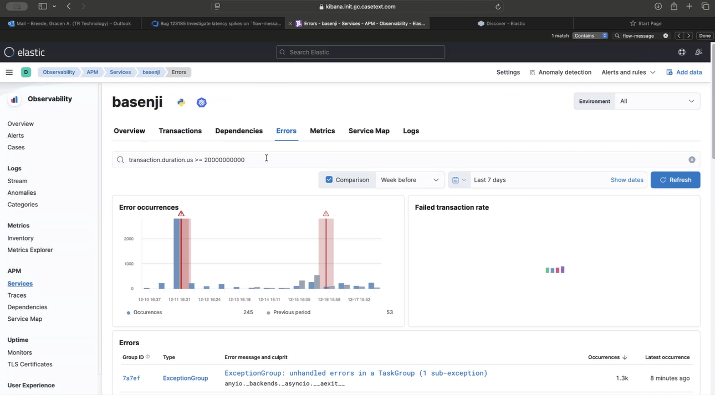

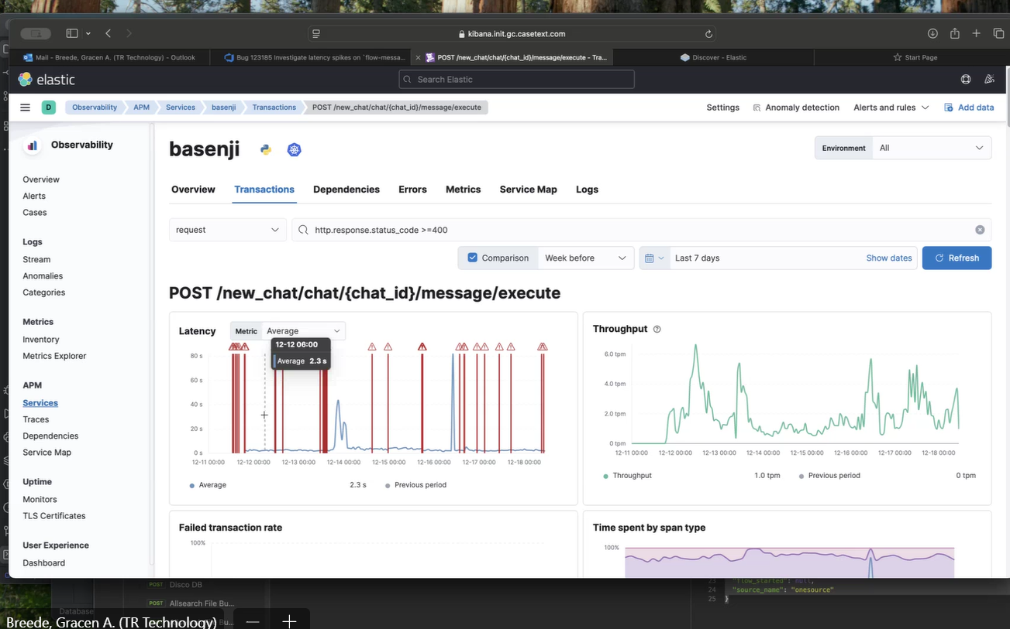

To look for debugging errors, should go on Kibana and look at the Transactions, Dependencies and Errors tabs.

# Pantheon ETL - Google Cloud Platform (GCP)

Pantheon works also for ETL (Extract, Transform and Load), that is the process performed to upload data into a Data Warehouse at the Google Cloud Platform (GCP) called Big Query. Pantheon is the other repository from Casetext (which is part of Thomson Reuters) for creating and executing skills, which are specific functions for the CoCouncil program.

# Jenkins

Its function is to deploy

# BIP: Basenji Intent Resolution

Its function is to deploy

# Canvas

Is a tool to be use on the Westlaw Precision page, which is used to read legal documents and ask questions about it by using the Thomson Reuters CoCounsil tool, it doesn’t read a document, but a webpage, for this we use the title of the article, for this we compare the embeddings for every paragraph element f the page and we compare it with the existent one of the prompt of the user.

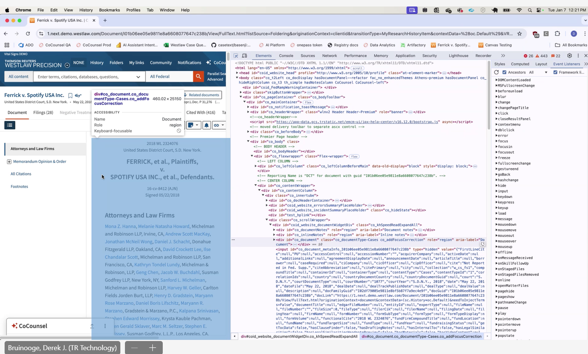

Xpath: Identifying a specific element within a DOM.

